Name: _________________ PD ID# ___ COSC 3380

HW 2:
(100 points)
(Due date found in the COSC 3380 Detailed Syllabus!)

1. (30 pts)

Answer the following questions about Files of Data Records and Indexes:

a. What operations are supported by the File of Data Records abstraction?

ANSWER:

b. What is an Index on a File of Data Records? What is a search key for an Index? Why do we need Indexes?

ANSWER:

c. What alternatives are available for the Data Entries k* in an Index?

ANSWER:

d. What is the difference between a primary Index and a secondary Index? What is a duplicate Data Entry K* in an Index? Can a primary Index contain duplicates?

ANSWER:

e. What is the difference between a clustered Index and an unclustered Index? If an Index contains Data Records as 'Data Entries', can the Index be unclustered?

ANSWER:

f. How many clustered Indexes can you create on a File of Data Records? Would you always create at least one clustered Index for a File of Data Records?

ANSWER:

2. (10 pts)

Assume a Table has 100,000 Data Record/rows and each Data Record/row occupies 100 bytes. Disk pages are 4000 bytes and the worst case time to access a page is D = 20ms. Estimate the average case time of doing an equality search on a candidate key under the following conditions.

a) An (unsorted) Heap File of Data Records with no Index.

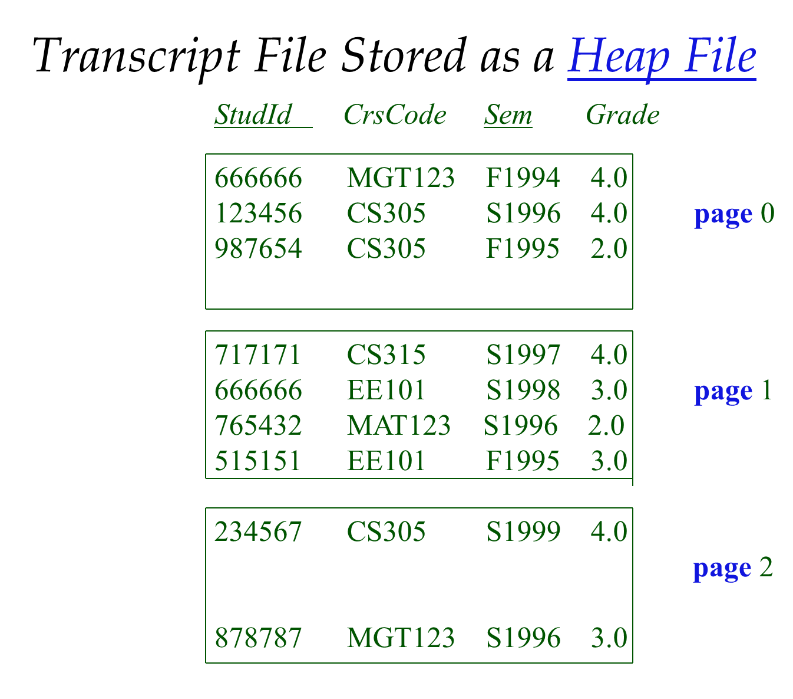

ANSWER:

- An unclustered B⁺ Tree Index in which each Data Entry K* occupies 20 bytes.

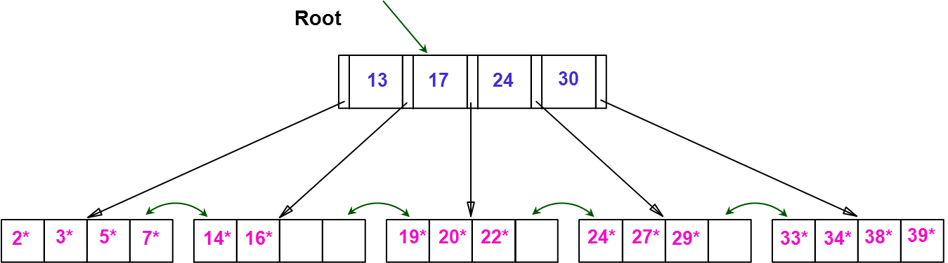
Height of this B+Tree is 1

COST = Height of the B⁺ Tree + 1 = log _{F} N + 1 = log N/ log F + 1
F = # pointers/index page or fanout F = 5
N = # Leaf (Data Entries k*) Pages N = 5

ANSWER:

3. (20 pts)

Consider a disk with a sector size of 512 bytes, 2000 tracks per surface,
50 sectors per track, five double-sided platters, and average seek time of 10 msec.

1. What is the capacity of a track in bytes? What is the capacity of each surface?
What is the capacity of the disk?

ANSWER:

2. How many cylinders does the disk have?

ANSWER:

3. Give examples of valid block sizes. Is 256 bytes a valid block size? 2048? 51200?

ANSWER:

4. If the disk platters rotate at 5400 rpm (revolutions per minute), what is the maximum rotational delay?

ANSWER:

5. If one track of data can be transferred per revolution, what is the transfer rate?

ANSWER:

4. (15 pts)

A particular Table in a relational database contains 100,000 Data Records/rows, each of which Data Record/row requires 200 bytes. A SELECT statement returns all Data Records/rows in the Table that satisfy an equality search on an attribute. Estimate the time in milliseconds to complete the query when each of the following Indexes on that attribute is used.

Assume a Page size of 4K bytes or 4,000 bytes and a Page access time of D = 20ms.

a. No Index (Heap File of Data Records)

ANSWER:

b. A Static Hash Index (with no overflow buckets/Pages).
Assume the cost of applying the hash function is H, negligible.

Static Hashing
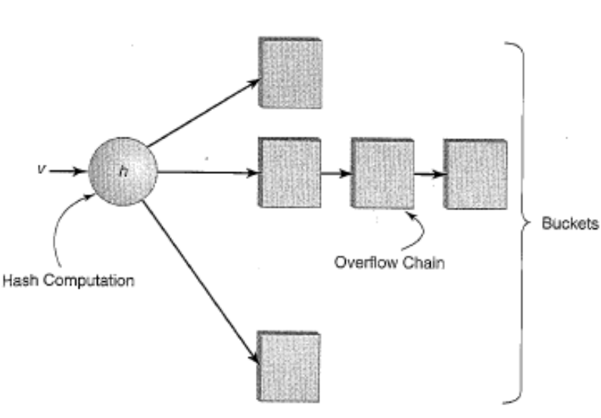
k*

H

ANSWER:

c. A clustered - sparse, unintegrated B⁺ Tree Index
Assume a Data Entry k* size of 100 bytes and assume 75% occupancy.

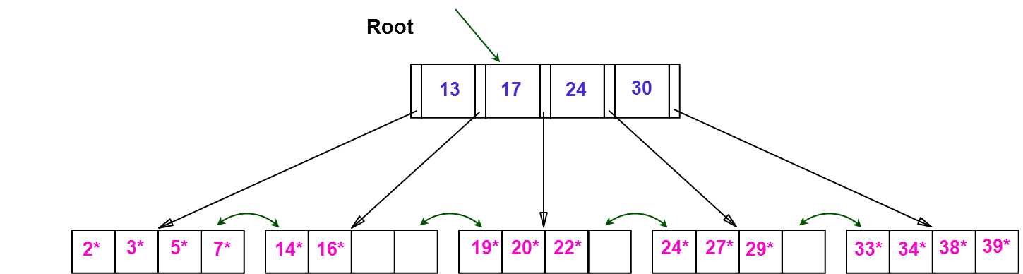

ANSWER:

5. (15 pts)

Estimate the time in milliseconds to insert a new Data Record/row in to the Table of Exercise 4.when each of the following Indexes is used:

a. No Index (Sorted File of Data Records)

ANSWER:

b. A Static Hash Index (no overflow buckets/Pages).
Assume the cost of applying the hash function is H, negligible.

Static Hashing
k*

H

ANSWER:

c. A clustered - sparse, unintegrated B⁺ Tree Index (with no node splitting required)

ANSWER:

6. (10 pts)
Suppose we have a Relation of 5,000 Data Records /tuples. Each Page/block can hold 5 Data Records /tuples, or 10 key-pointer pairs (Data Entries k*). The Indexes built on the key field of the Relation (thus no duplicate search keys) and the file is sorted according to the key. Answer the questions below about the space required for each Index (just the Index, not the Data as well).
a. How many Pages/blocks do we need for a dense Index of this Relation?
ANSWER:

b. How many Pages/blocks do we need for a sparse Index of this Relation?
ANSWER:

